

SE-401L Human Computer Interaction Lab
Sir Dr. Hamid Ullah
23 May 2026

HCI OEL
Ali Khan – 23MDSWE248
Visit Github Figma Design
University of Engineering and Technology Mardan

Interactive Prototype Design and Cognitive Walkthrough Evaluation of AegisNet Smart Surveillance System

Project Title
AegisNet – AI Powered Smart City Surveillance and Criminal Tracking System

Introduction
Human Computer Interaction (HCI) focuses on designing systems that are user-friendly, efficient, and interactive for end users. The purpose of this Open-Ended Lab (OEL) is to design an interactive prototype of a proposed Final Year Project (FYP) idea using Figma and evaluate its usability through the Cognitive Walkthrough evaluation method.
The selected FYP idea is “AegisNet”, an AI-powered smart surveillance and criminal tracking system designed for smart city environments. The system is intended to assist law enforcement agencies by monitoring multiple CCTV feeds, detecting suspicious activities, generating alerts, and tracking suspects across multiple cameras.
The prototype was designed in Figma to simulate the real interaction flow of the proposed system. The prototype includes login functionality, live monitoring dashboards, alert systems, tracking interfaces, suspect profiles, and settings management screens.

Objective
The main objectives of this OEL are:
- To design an interactive prototype of the proposed FYP system using Figma.
- To create a user-friendly interface for law enforcement monitoring.
- To simulate the functionality of smart surveillance operations.
- To evaluate the usability of the system using Cognitive Walkthrough evaluation.
- To identify usability issues and suggest improvements.

Proposed System Overview
AegisNet is a smart surveillance platform designed for police and security departments. The system uses artificial intelligence and computer vision to analyze CCTV feeds and detect suspicious activities.
The system categorizes alerts into two levels:

Low Threat Alert
A low-threat alert is generated when the system detects a weapon or suspicious object without aggressive behavior. The system sends:
- Alert notification
- Snapshot image
- Short evidence clip

High Threat Alert
A high-threat alert is generated when suspicious or violent behavior is detected, such as:
- Aggressive pose with weapon
- Attack posture
- Threatening movement
In this case, the system activates:
- Multi-camera suspect tracking
- Live location updates
- Re-identification monitoring
- Escape route prediction

Tools and Technologies Used
The following tools were used during the prototype design process:

Tool | Purpose
Figma | UI/UX Design and Interactive Prototype
Google Chrome | Prototype Testing
AI Design Concepts | Interface Planning and System Flow

Prototype Design
The prototype was designed using a dark-themed modern dashboard interface suitable for police and surveillance operations. The design focuses on clarity, visibility, and quick interaction during emergency situations.
The prototype contains seven main screens.

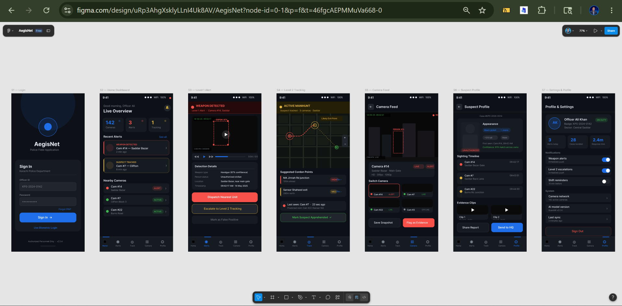
Figure 1 Seven Screens prototype for AegisNet

Screen Descriptions
Below is the description and detail of each screen designed in figama

1. Login Screen
The login screen allows police officers to securely sign into the system using:
- Officer ID
- Password
- Biometric login option
The design uses a minimal and secure interface to maintain professional appearance.

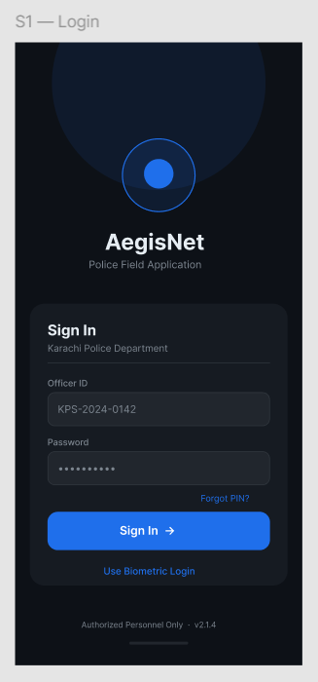

2. Home Dashboard
The dashboard provides an overview of:
- Total active cameras
- Active alerts
- Tracking operations
- Recent alerts
- Nearby camera statuses
This screen acts as the central control panel for monitoring activities.
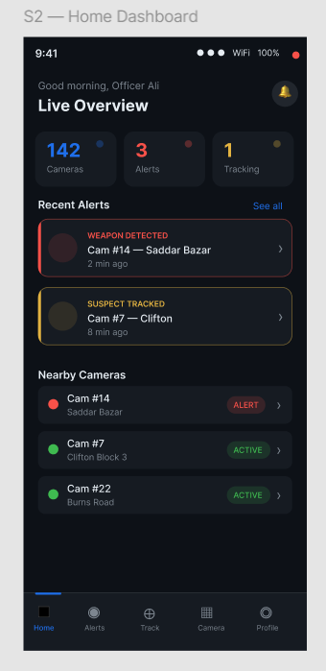

3. Level 1 Alert Screen
This screen displays low-threat alerts where weapons are detected without suspicious behavior.
The interface shows:
- Camera information
- Detection confidence
- Timestamp
- Evidence video clip
- Action buttons
Users can:
- Dispatch nearest unit
- Escalate to tracking mode
- Mark alert as false positive
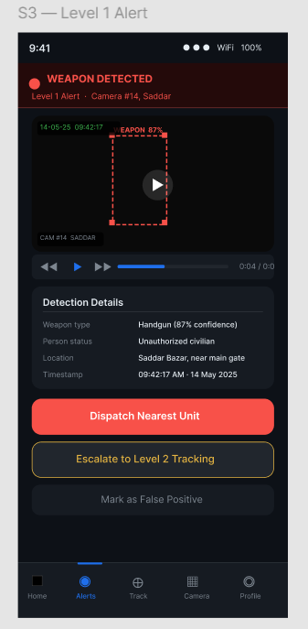

4. Level 2 Tracking Screen
This screen is activated during high-threat situations.
Features include:
- Multi-camera suspect tracking
- Live movement path
- Suggested interception points
- Predicted escape routes
- Tracking status updates
This screen represents the intelligent surveillance capability of the system.
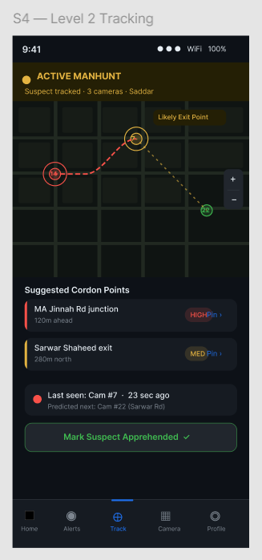

5. Camera Feed Screen
The camera feed interface allows users to:
- View live CCTV feed
- Switch between cameras
- Save snapshots
- Flag suspicious events as evidence
The screen also displays alert indicators and live camera status.
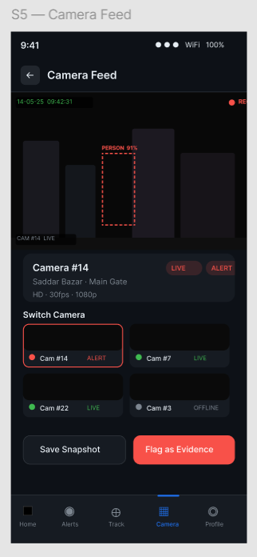

6. Suspect Profile Screen
This screen stores information related to tracked suspects including:
- Appearance description
- Clothing details
- Sighting timeline
- Camera history
- Evidence clips
The screen helps officers review suspect-related information efficiently.
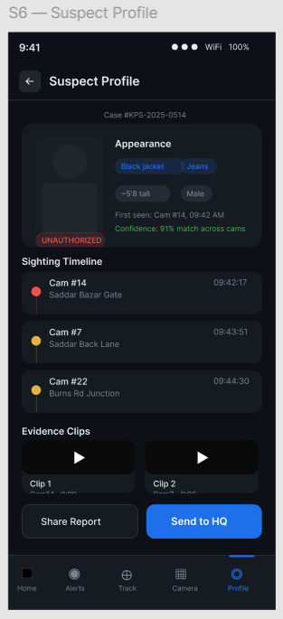

7. Settings and Profile Screen
The settings interface allows users to manage:
- Alert preferences
- Escalation notifications
- Shift reminders
- Camera network settings
- AI model version information
The profile section also displays officer information and statistics.
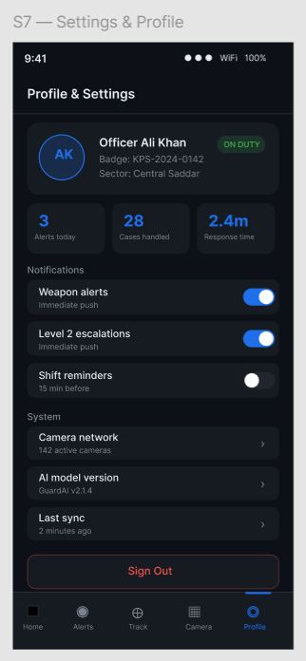

Design Principles Used
The following HCI principles were considered during prototype design:

Consistency
Consistent colors, icons, buttons, and typography were used throughout all screens.

Visibility
Important actions and alerts were highlighted using bright colors for quick recognition.

Feedback
The system provides immediate visual feedback after user interactions.

Simplicity
The interface avoids unnecessary complexity to support fast decision-making.

Accessibility
Large buttons and readable text improve usability during emergency situations.

Navigation Flow
The prototype includes interactive navigation between screens. Users can:
- Move from login to dashboard
- Open alert details
- Navigate to tracking screen
- Access camera feeds
- View suspect profiles
- Open settings screen
The clickable interactions simulate real-world application behavior.

Cognitive Walkthrough Evaluation
Cognitive Walkthrough is a usability evaluation method used to determine how easily users can complete tasks within a system. The evaluation focuses on the user’s understanding, actions, and system responses.
The following questions were used during evaluation:
- Will the user know what to do?
- Will the user notice the correct action?
- Will the user understand the system response?
- Will the user successfully complete the task?

User Tasks for Evaluation
Four important user tasks were selected for evaluation.

Task 1: Officer Login into the System

Steps
- Open the application.
- Enter Officer ID.
- Enter password.
- Click “Sign In”.

Evaluation

Will the user know what to do?
Yes. The login fields are clearly labeled and easy to understand.

Will the user notice the correct action?
Yes. The Sign In button is highly visible using a bright blue color.

Will the user understand the system response?
Yes. After login, the user is redirected to the dashboard screen.

Will the user successfully complete the task?
Yes. The login process is simple and familiar.

Usability Problems
- Password visibility toggle is missing.
- No error message screen is shown for invalid login.

Suggested Improvements
- Add show/hide password option.
- Add proper authentication feedback messages.

Task 2: View Alert Details

Steps
- Open the dashboard.
- Select a recent alert.
- Open alert details screen.
- Review evidence clip and detection details.

Evaluation

Will the user know what to do?
Yes. Alert cards are clearly visible in the dashboard.

Will the user notice the correct action?
Yes. Each alert card appears clickable and visually highlighted.

Will the user understand the system response?
Yes. The detailed alert screen provides additional information and evidence.

Will the user successfully complete the task?
Yes. Navigation between dashboard and alert details is straightforward.

Usability Problems
- Alert priority labels could be larger.
- Some buttons are close together on smaller screens.

Suggested Improvements
- Increase alert badge visibility.
- Add spacing between action buttons.

Task 3: Escalate Alert to Level 2 Tracking

Steps
- Open Level 1 Alert screen.
- Click “Escalate to Level 2 Tracking”.
- Open tracking dashboard.
- Monitor suspect movement.

Evaluation

Will the user know what to do?
Yes. The escalation button is clearly labeled.

Will the user notice the correct action?
Yes. The button is visually emphasized.

Will the user understand the system response?
Yes. The system transitions to the tracking interface showing active monitoring.

Will the user successfully complete the task?
Yes. The flow between alert handling and tracking is understandable.

Usability Problems
- Tracking map may initially appear complex for new users.
- Escape route indicators may require legends or labels.

Suggested Improvements
- Add onboarding hints or tooltips.
- Add color legends for route indicators.

Task 4: View Suspect Profile and Evidence

Steps
- Open suspect tracking screen.
- Select suspect profile.
- Review appearance details and evidence clips.
- Share report with headquarters.

Evaluation

Will the user know what to do?
Yes. The suspect profile option is accessible from the navigation menu.

Will the user notice the correct action?
Yes. Evidence clips and buttons are visible and properly grouped.

Will the user understand the system response?
Yes. The interface clearly displays suspect-related information.

Will the user successfully complete the task?
Yes. Users can easily access and review suspect data.

Usability Problems
- Some evidence sections may appear small on mobile screens.
- Clip previews may require larger playback controls.

Suggested Improvements
- Increase evidence section size.
- Improve media control accessibility.

Overall Cognitive Walkthrough Findings
The evaluation showed that the prototype provides a user-friendly and intuitive interaction flow. The navigation structure is clear, and users can successfully perform major surveillance tasks with minimal confusion.
The design effectively supports:
- Fast alert recognition
- Emergency decision-making
- Real-time monitoring
- Multi-camera tracking workflows
However, some usability improvements are still needed in:
- feedback messages,
- button spacing,
- onboarding guidance,
- and accessibility enhancements.

Conclusion
The AegisNet prototype successfully demonstrates the interface and interaction flow of an AI-powered smart surveillance and criminal tracking system. The prototype includes all required screens, interactive navigation, and modern interface design principles.
The Cognitive Walkthrough evaluation identified that the system is generally easy to use and supports efficient task completion for police officers and surveillance operators. The evaluation also helped identify areas for usability improvement.
This prototype provides a strong foundation for the future implementation of the proposed Final Year Project.

THE END

